Arexis
Genetic Database Tool

Module Description

SQL Layer

Version 1

Prevas AB

Contents

1 GeneraL 4
2 Description 4
2.1 Implementation Decisions 4
2.1.1 A mix of explicit and implicit relations 4
2.1.2 Cached columns 4
2.2 Users 4
2.2.1 GdbAdm 4
2.2.2 GdbUser 4
2.3 Table groups 5
2.3.1 Projects and Users 5
2.3.1.1 Table Projects 5
2.3.1.2 Table Users 5
2.3.1.3 Table Privileges_ 6
2.3.1.4 Table Roles_ 6
2.3.1.5 Table R_Prj_Rol 6
2.3.1.6 Table R_Rol_Pri 6
2.3.2 Species 7
2.3.2.1 Table Species 7
2.3.2.2 Table Chromosomes 8
2.3.2.3 Table L_Markers 8
2.3.2.4 Table L_Alleles 8
2.3.2.5 Table R_Prj_Spc 8
2.3.3 Sampling Units 9
2.3.3.1 Table Sampling_Units 10
2.3.3.2 Table Sampling_Units_Log 10
2.3.3.3 Table Individuals 11
2.3.3.4 Table Individuals_Log 11
2.3.3.5 Table Samples 12
2.3.3.6 Table Samples_Log 12
2.3.3.7 Table Groupings 12
2.3.3.8 Table Groupings_Log 13
2.3.3.9 Table Groups 13
2.3.3.10 Table Groups_Log 13
2.3.3.11 Table R_Prj_SU 13
2.3.3.12 Table R_Ind_Grp 14
2.3.4 Phenotypes 15
2.3.4.1 Table U_Variables 16
2.3.4.2 Table U_Variables_Log 16
2.3.4.3 Table U_Variable_Sets 16
2.3.4.4 Table U_Variable_Sets_Log 16
2.3.4.5 Table Variables 17
2.3.4.6 Table Variables_Log 17
2.3.4.7 Table Variable_Sets 17
2.3.4.8 Table Variable_Sets_Log 18
2.3.4.9 Table Phenotypes 18
2.3.4.10 Table Phenotypes_Log 18
2.3.4.11 Table R_Var_Set 18
2.3.4.12 Table R_U_Var_Set 19
2.3.4.13 Table R_Uvid_Vid 19
2.3.5 Genotypes 20
2.3.5.1 Table U_Markers 21
2.3.5.2 Table U_Markers_Log 22
2.3.5.3 Table U_Marker_Sets 22
2.3.5.4 Table U_Marker_Sets_Log 22
2.3.5.5 Table U_Alleles 22
2.3.5.6 Table U_Alleles_Log 23
2.3.5.7 Table Markers 23
2.3.5.8 Table Markers_Log 23
2.3.5.9 Table Marker_Sets 24
2.3.5.10 Table Marker_Sets_Log 24
2.3.5.11 Table Alleles 24
2.3.5.12 Table Alleles_Log 24
2.3.5.13 Table Genotypes 25
2.3.5.14 Table Genotypes_Log 25
2.3.5.15 Table U_Positions 26
2.3.5.16 Table Positions 26
2.3.5.17 Table R_Umid_Mid 26
2.3.5.18 Table R_Uaid_Aid 26
2.3.6 Analyses 28
2.3.6.1 Table Filters 28
2.3.6.2 Table Filters_Log 29
2.3.6.3 Table File_Generations 29
2.3.6.4 Table File_Generations_Log 30
2.3.6.5 Table Data_Files 30
2.3.6.6 Table Data_Files_Log 30
2.3.6.7 Table R_Fg_Flt 30
2.4 Source files 31
3 Development environment 31
4 Version Handling 31
5 References 31
6 Document Versions 31

GeneraL
This document describes the SQL Layer in the GDB system.

Description

Implementation Decisions

A mix of explicit and implicit relations
A relation between two tables is always implemented by having columns in the first table refer to primary key columns in the other table. In Oracle the referring columns are normally declared as a FOREIGN KEY columns, thus making Oracle aware of the relation. Oracle uses this information in two ways depending on the type of FOREIGN KEY declaration:

- If a column is declared as FOREIGN KEY Oracle prevents rows from being deleted in the referred table, if there are any referring rows in the referring table.
- If a column is declared as FOREIGN KEY ON DELETE CASCADE Oracle automatically deletes all referring rows in the referring table when a referred row is deleted in the referred table.

Unfortunately, due to severe performance problems for instance when a sampling unit should be deleted, not all columns implementing relations are declared as FOREIGN KEY columns in the GDB database. Oracle is therefore not aware of these relations.

Cached columns
Some tables have cached columns related to primary key columns in other tables although this introduces relational redundancy in the database. The benefit is that it makes it possible to create indexes on the columns thus boosting the performance.

An example is the table genotypes, which refers to the table individuals, which in turn refers to the table sampling_units. Although not needed the primary key of the table sampling_units (suid) is referred to from the table genotypes, thus making it possible to create an index on suid in the table.

Users

GdbAdm
The GdbAdm user owns all the tables, views, packages and sequences. GdbAdm has the privileges to create and delete all the objects in the GDB database.

GdbUser
The GdbUser only has privileges to select, insert, update and delete rows in the GDB database tables. The web server logs on to Oracle as this user.

Table groups

Projects and Users
The logical model for projects and users is displayed below. Refer to reference 1 for a more detailed description.
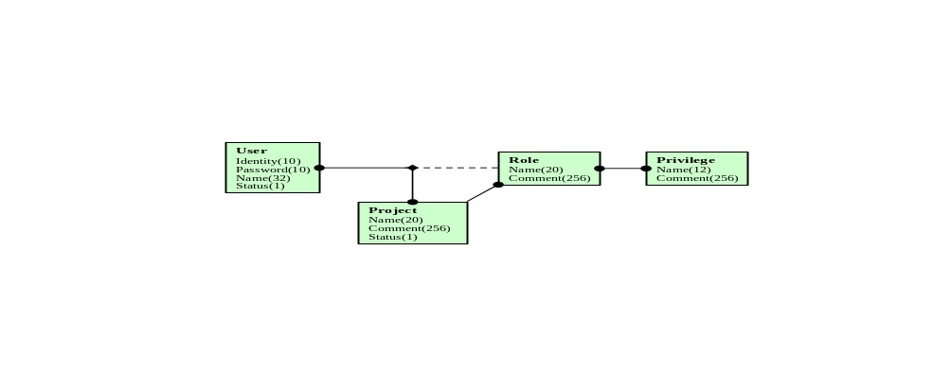
The logical model is mapped to the following physical model:
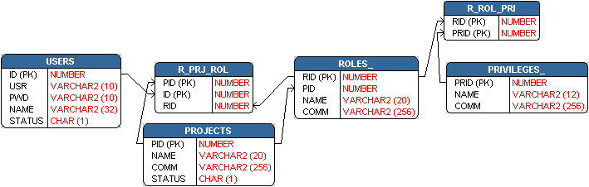

Table Projects

Column | Type | Null | Comment
Pid | Number(38) | No | Primary key with range 1001-2000000000.  Values must be taken from the sequence Projects_Seq
Name | Varchar2(20) | No | Project name. Must be unique
Comm | Varchar2(256) | Yes | Comment
Status | Char(1) | No | ‘E’ = enabled, ‘D’ = disabled

Table Users

Column | Type | Null | Comment
Id | Number(38) | No | Primary key with range 1001-2000000000.  Values must be taken from the sequence Users_Seq
Usr | Varchar2(10) | No | User name. Must be unique
Pwd | Varchar2(10) | No | User password. Not encrypted!!!
Name | Varchar2(32) | Yes | Long user name
Status | Char(1) | No | ‘E’ = enabled, ‘D’ = disabled

Table Privileges_

Column | Type | Null | Comment
Prid | Number(38) | No | Primary key with range 1-42.
Name | Varchar2(12) | No | Privilege name. Must be unique
Comm | Varchar2(256) | Yes | Comment

This table is static and it is initialized during system installation. It must not be modified, except possibly for the column Comm.

Table Roles_

Column | Type | Null | Comment
Rid | Number(38) | No | Primary key with range 1001-2000000000.  Values must be taken from the sequence Roles_Seq
Pid | Number(38) | No | References the column Pid in table Projects. Not declared as FOREIGN KEY.
Name | Varchar2(20) | No | Role name. Must be unique together with pid.
Comm | Varchar2(256) | Yes | Comment

Table R_Prj_Rol

Column | Type | Null | Comment
Pid | Number(38) | No | Primary key, which references the column Pid in, table Projects. Declared as FOREIGN KEY ON DELETE CASCADE.
Id | Number(38) | No | Primary key, which references the column Id in, table Users. Declared as FOREIGN KEY ON DELETE CASCADE.
Rid | Number(38) | No | References the column Rid in table Roles. Declared as FOREIGN KEY ON DELETE CASCADE.

Table R_Rol_Pri

Column | Type | Null | Comment
Rid | Number(38) | No | Primary key, which references the column Rid in, table Roles_. Declared as FOREIGN KEY ON DELETE CASCADE.
Prid | Number(38) | No | Primary key, which references the column Prid in, table Privileges_. Declared as FOREIGN KEY ON DELETE CASCADE.

Species
The logical model for species is displayed below. Refer to reference 1 for more details.
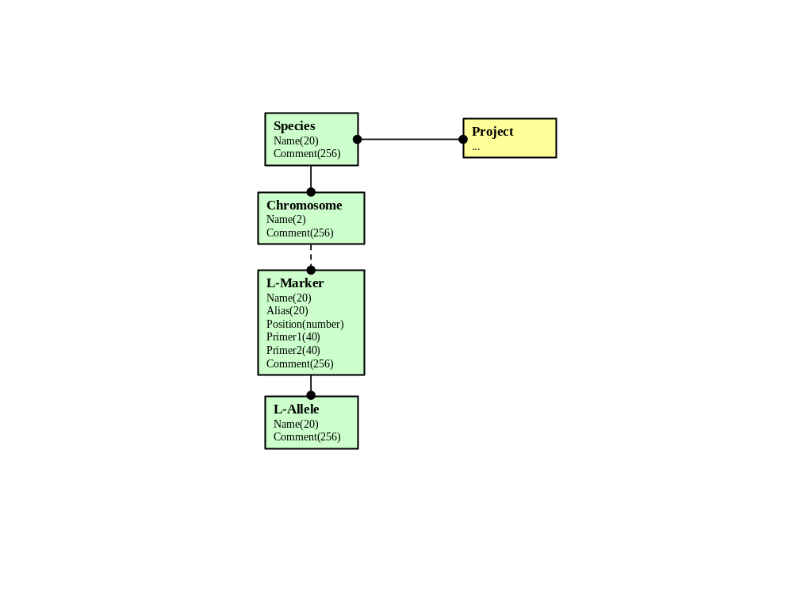
The logical model is mapped to the following physical model:

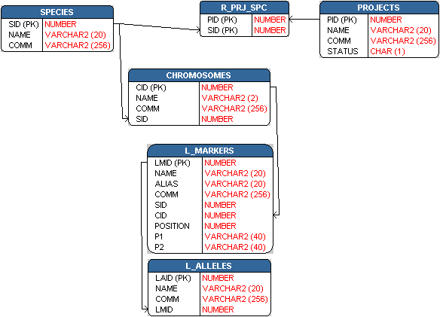

Table Species

Column | Type | Null | Comment
Sid | Number(38) | No | Primary key with range 1001-2000000000.
Name | Varchar2(20) | No | The name of the species, must be unique.
Comm | Varchar2(256) | Yes | Comment

Table Chromosomes

Column | Type | Null | Comment
Cid | Number(38) | No | Primary key with range 1001 to 2000000000
Name | Varchar2(2) | No | Name of the chromosome, must be unique together with sid.
Comm | Varchar2(256) | Yes | Comment
Sid | Number(38) | No | References the column sid in table Species. Not declared as FOREIGN KEY.

Table L_Markers

Column | Type | Null | Comment
Lmid | Number (38) | No | Primary key with range 1001 – 2000000000.
Name | Varchar2(20) | No | Name of the library marker. Must be unique together with sid.
Alias | Varchar2(20) | Yes | Alias of the library marker.
Comm | Varchar2(256) | Yes | Comment
Sid | Number(38) | No | References the column sid in table Species. Not declared as FOREIGN KEY.
Cid | Number(38) | No | References the column cid in table Chromosomes. Not declared as FOREIGN KEY.
P1 | Varchar2(40) | Yes | Primer 1
P2 | Varchar2(40) | Yes | Primer 2
Position | Number | Yes | Absolute chromosome position (cM)

Table L_Alleles

Column | Type | Null | Comment
Laid | Number(38) | No | Primary key with range 1001 – 2000000000
Name | Varchar2(20) | No | Name of the library allele. Must be unique together with lmid.
Comm | Varchar(256) | Yes | Comment
Lmid | Number(38) | No | References the column lmid in table L_Markers. Not declared as PRIMARY KEY.

Table R_Prj_Spc

Column | Type | Null | Comment
Pid | Number(38) | No | References the column pid in table Projects. Not declared as FOREIGN KEY.
Sid | Number(38) | No | References the column sid in table Species. Not declared as FOREIGN KEY.

Sampling Units
The logical model for sampling units is displayed below, refer to reference 1 for more details.
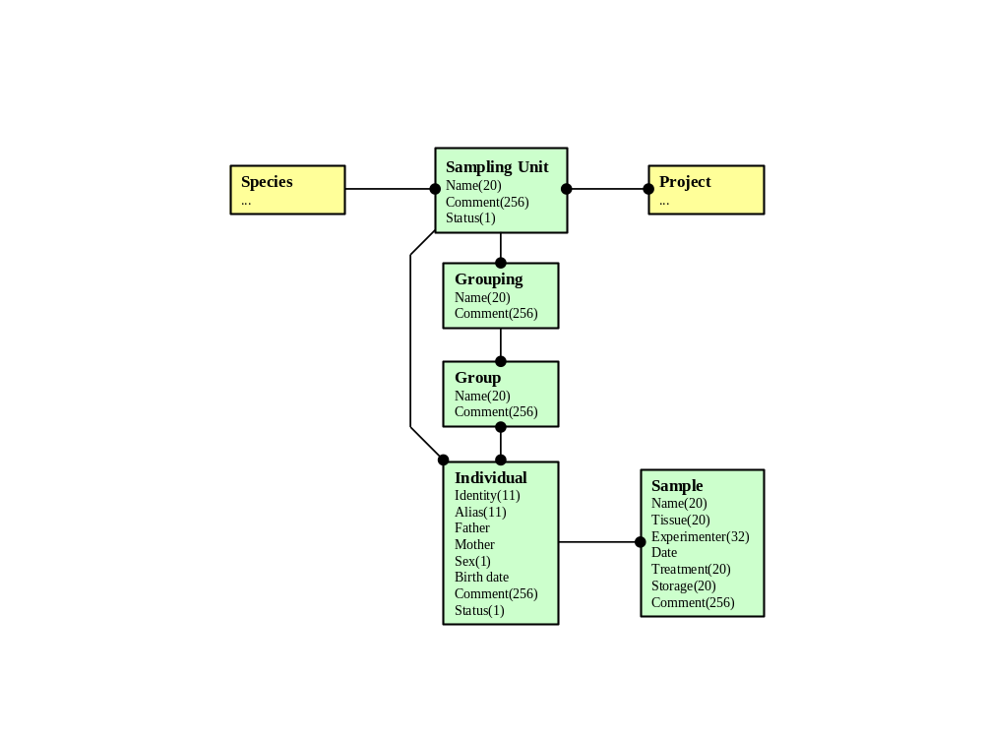
The logical model is mapped to the following physical model:

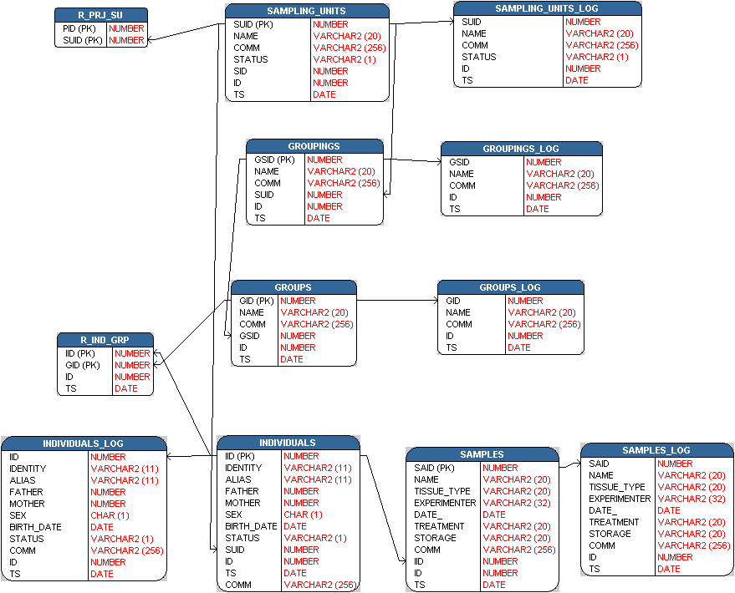

Table Sampling_Units

Column | Type | Null | Comment
Suid | Number(38) | No | Primary key with range 1001 – 2000000000.
Name | Varchar2(20) | No | Name of the sampling unit. Must be unique.
Comm | Varchar2(256) | Yes | Comment
Status | Varchar2(1) | No | Status of the sampling unit. Valid values: ‘E’ and ‘D’. (Enabled an Disabled)
Sid | Number(38) | No | References the column sid in table Species. Not declared as FOREIGN KEY.
Id | Number(38) | No | References the column id in table Users. Not declared as FOREIGN KEY.
Ts | Date | No | The time and date the sampling unit was updated.

Table Sampling_Units_Log

Column | Type | Null | Comment
Suid | Number(38) | No | References the column suid in table Sampling_Units. Declared as FOREIGN KEY ON DELETE CASCADE.
Name | Varchar2(20) | No | Name of the sampling unit.
Comm | Varchar2(256) | Yes | Comment
Status | Varchar2(1) | No | Status of the sampling unit. Valid values: ‘E’ and ‘D’. (Enabled an Disabled)
Id | Number(38) | No | References the column id in table Users. Not declared as FOREIGN KEY.
Ts | Date | No | The time and date the sampling unit was updated.

Table Individuals

Column | Type | Null | Comment
Iid | Number(38) | No | Primary key with range 1001 – 2000000000.
Identity | Varchar2(11) | No | External name of this individual. Must be unique together with suid.
Alias | Varchar2(11) | Yes | Alternative name
Father | Number(38) | Yes | Father of this individual. References the column iid in table Individuals.
Mother | Number(38) | Yes | Mother of this individual. References the column iid in table Individuals.
Sex | Char(1) | No | Sex of this individual. Valid values: ‘M’, ‘F’ and ‘U’
Birth_date | Date | Yes | Birth date of this individual.
Status | Varchar2(1) | No | Status of this individual. Valid values: ‘E’ and ‘D’.
Suid | Number(38) | No | References the column suid in table Sampling_units. Not declared as FOREIGN KEY.
Id | Number(38) | No | References the column id in table Users. Not declared as FOREIGN KEY.
Ts | Date | No | Time and date this individual was updated.
Comm | Varchar2(256) | Yes | Comment.

Table Individuals_Log

Column | Type | Null | Comment
Iid | Number(38) | No | References the column iid in table Individuals. Declared as FOREIGN KEY ON DELETE CASCADE.
Identity | Varchar2(11) | No | External name of this individual. Must be unique together with suid.
Alias | Varchar2(11) | Yes | Alternative name
Father | Number(38) | Yes | Father of this individual. References the column iid in table Individuals.
Mother | Number(38) | Yes | Mother of this individual. References the column iid in table Individuals.
Sex | Char(1) | No | Sex of this individual.
Birth_date | Date | Yes | Birth date of this individual.
Status | Varchar2(1) | No | Status of this individual.
Comm | Varchar2(256) | Yes | Comment.
Id | Number(38) | No | References the column id in table Users. Not declared as FOREIGN KEY.
Ts | Date | No | Time and date this individual was updated.

Table Samples

Column | Type | Null | Comment
Said | Number(38) | No | Primary key with range 1001 to 2000000000.
Name | Varchar2(20) | No | Name of this sample. Must be unique together with iid.
Tissue_type | Varchar2(20) | Yes | Type of tissue
Experimenter | Varchar2(32) | Yes | Name of experimenter
Date_ | Date | Yes | Date this sample was taken.
Treatment | Varchar2(20) | Yes | Sample treatment
Storage | Varchar2(20) | Yes | Storage location
Comm | Varchar2(256) | Yes | Comment.
Iid | Number(38) | No | References the column iid in table Individuals. Declared as FOREIGN KEY ON DELETE CASCADE.
Id | Number(38) | No | References the column id in table Users. Declared as FOREIGN KEY ON DELETE CASCADE.
Ts | Date | No | Date this sample was taken.

Table Samples_Log
Column | Type | Null | Comment
Said | Number(38) | No | References the column said in table Samples. Declared as FOREIGN KEY ON DELETE CASCADE.
Name | Varchar2(20) | No | Type of tissue
Tissue_type | Varchar2(20) | Yes | Name of experimenter
Experimenter | Varchar2(32) | Yes | Date this sample was taken.
Date_ | Date | Yes | Sample treatment
Treatment | Varchar2(20) | Yes | Storage location
Storage | Varchar2(20) | Yes | Type of tissue
Comm | Varchar2(256) | Yes | Comment.
Id | Number(38) | No | References the column id in table Users. Not declared as FOREIGN KEY.
Ts | Date | No | Date this sample was taken.

Table Groupings
Column | Type | Null | Comment
Gsid | Number(38) | No | Primary key with range 1001 – 2000000000.
Name | Varchar2(20) | No | Name of this grouping. Must be unique together with suid.
Comm | Varchar2(256) | Yes | Comment.
Suid | Number(38) | No | References the column suid in table Sampling_Units. Not declared as FOREIGN KEY.
Id | Number(38) | No | References the column id in table Users. Not declared as FOREIGN KEY.
Ts | Date | No | Time and date this grouping was updated.

Table Groupings_Log
Column | Type | Null | Comment
Gsid | Number(38) | No | References the column gsid in table Groupings. Declared as FOREIGN KEY ON DELETE CASCADE.
Name | Varchar2(20) | No | Name of this grouping.
Comm | Varchar2(256) | Yes | Comment.
Id | Number(38) | No | References the column id in table Users. Not declared as FOREIGN KEY.
Ts | Date | No | Time and date this grouping was updated.

Table Groups
Column | Type | Null | Comment
Gid | Number(38) | No | Primary key with range 1001 – 2000000000.
Name | Varchar2(20) | No | Name of the group. Must be unique together with gsid.
Comm | Varchar2(256) | Yes | Comment.
Gsid | Number(38) | No | References the column gsid in table Groupings. Declared as FOREIGN KEY ON DELETE CASCADE.
Id | Number(38) | No | References the column id in table Users. Not declared as FOREIGN KEY.
Ts | Date | No | Date the group was updated.

Table Groups_Log
Column | Type | Null | Comment
Gid | Number(38) | No | References the column gid in table Groups. Declared as FOREIGN KEY ON DELETE CASCADE.
Name | Varchar2(20) | No | Name of the group.
Comm | Varchar2(256) | Yes | Comment.
Id | Number(38) | No | References the column id in table Users. Not declared as FOREIGN KEY.
Ts | Date | No | Date the group was updated.

Table R_Prj_SU
Column | Type | Null | Comment
Pid | Number(38) | No | Primary key, references the column pid in table Projects. Declared as FOREIGN KEY ON DELETE CASCADE.
Suid | Number(38) | No | Primary key, references the column suid in table Sampling_Units. Declared as FOREIGN KEY ON DELETE CASCADE.

Table R_Ind_Grp
Column | Type | Null | Comment
Iid | Number(38) | No | Primary key, references the column iid in table Individuals. Declared as FOREIGN KEY ON DELETE CASCADE.
Gid | Number(38) | No | Primary key, references the column gid in table Groupings. Declared as FOREIGN KEY ON DELETE CASCADE.
Id | Number(38) | No | References the column id in table Users. Not declared as FOREIGN KEY.
Ts | Date | No | Date the relation was created.

Phenotypes
The logical model for phenotypes is displayed below. Refer to reference 1 for more details.
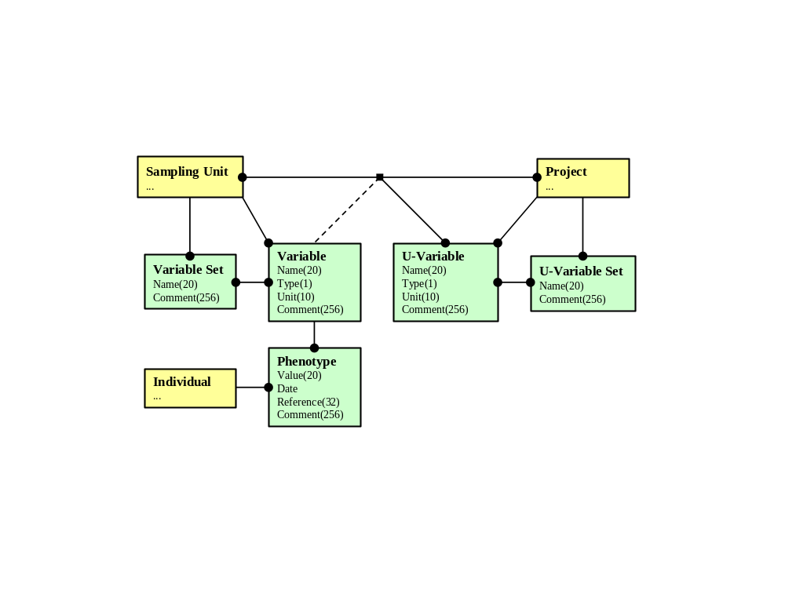
The logical model is mapped to the following physical model:

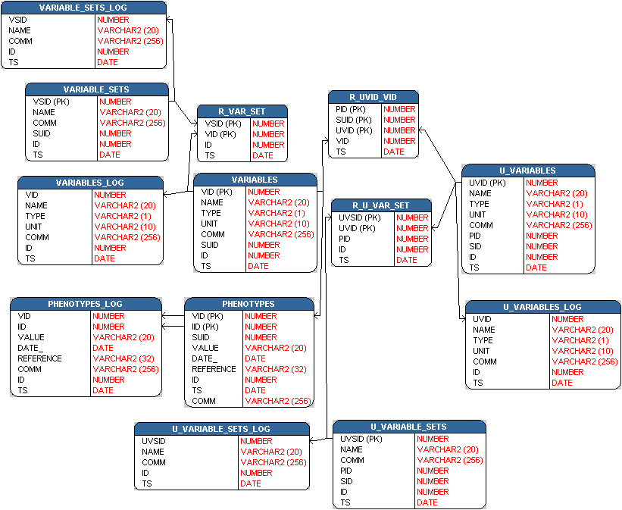

Table U_Variables
Column | Type | Null | Comment
Uvid | Number(38) | No | Primary key with range 1001 – 2000000000.
Name | Varchar2(20) | No | Name of unified variable, must be unique together with pid and sid.
Type | Varchar2(1) | No | Valid values: ‘E’ and ‘N’. (Enumeration and Number)
Unit | Varchar2(10) | Yes | Measurement unit
Comm | Varchar2(256) | Yes | Comment.
Pid | Number(38) | No | References the column pid in table Projects. Not declared as FOREIGN KEY.
Sid | Number(38) | No | References the column sid in table Species. Not declared as FOREIGN KEY
Id | Number(38) | No | References the column id in table Users. Not declared as FOREIGN KEY
Ts | Date | No | Date the unified variable was updated.

Table U_Variables_Log
Column |  | Type |  | Null |  | Comment
Uvid | Number(38) |  | No |  | References the column uvid in table U_Variables. Not declared as FOREIGN KEY
Name | Varchar2(20) |  | No |  | Name of unified variable.
Type | Varchar2(1) |  | No |  | Valid values: ‘E’ and ‘N’. (Enumeration and Number)
Unit | Varchar2(10) |  | Yes |  | Measurement unit
Comm | Varchar2(256) |  | Yes |  | Comment.
Id | Number(38) |  | No |  | References the column id in table Users. Not declared as FOREIGN KEY
Ts | Date |  | No |  | Date the unified variable was updated.

Table U_Variable_Sets
Column | Type | Null | Comment
Uvsid | Number(38) | No | Primary key with range 1001 – 2000000000.
Name | Varchar2(20) | No | Name of the unified variable set. Must be unique together with pid and sid.
Comm | Varchar2(256) | Yes | Comment
Pid | Number(38) | No | References the column pid in table Projects. Not declared as FOREIGN KEY.
Sid | Number(38) | No | References the column sid in table Species. Not declared as FOREIGN KEY.
Id | Number(38) | No | References the column id in table Users. Not declared as FOREIGN KEY.
Ts | Date | No | Date and time of update.

Table U_Variable_Sets_Log
Column | Type | Null | Comment
Uvsid | Number(38) | No | References the column uvsid in table U_Variable_Sets. Not declared as FOREIGN KEY.
Name | Varchar2(20) | No | Name of the unified variable set.
Comm | Varchar2(256) | Yes | Comment
Id | Number(38) | No | References the column id in table Users. Not declared as FOREIGN KEY.
Ts | Date | No | Date and time of update.

Table Variables
Column | Type | Null | Comment
Vid | Number(38) | No | Primary key with range 1001 – 2000000000.
Name | Varchar2(20) | No | Name of the variable. Must be unique together with suid.
Type | Varchar2(1) | No | Valid values: ‘E’ and ‘N’. (Enumeration and Number)
Unit | Varchar2(10) | Yes | Measurement unit
Comm | Varchar2(256) | Yes | Comment.
Suid | Number(38) | No | References the column suid in table Sampling_Units. Not declared as FOREIGN KEY.
Id | Number(38) | No | References the column id in table Users. Not declared as FOREIGN KEY.
Ts | Date | No | Date and time of update.

Table Variables_Log
Column | Type | Null | Comment
Vid | Number(38) | No | References the column vid instable Variables. Declared as FOREIGN KEY ON DELETE CASCADE.
Name | Varchar2(20) | No | Name of the variable.
Type | Varchar2(1) | No | Valid values: ‘E’ and ‘N’. (Enumeration and Number)
Unit | Varchar2(10) | Yes | Measurement unit
Comm | Varchar2(256) | Yes | Comment.
Id | Number(38) | No | References the column id in table Users. Not declared as FOREIGN KEY.
Ts | Date | No | Date and time of update.

Table Variable_Sets
Column | Type | Null | Comment
Vsid | Number(38) | No | Primary key with range of 1001 – 2000000000.
Name | Varchar2(20) | No | Name of the variable set. Must be unique together with suid.
Comm | Varchar2(256) | Yes | Comment.
Suid | Number(38) | No | References the column suid in table Sampling_Units. Not declared as FOREIGN KEY.
Id | Number(38) | No | References the column id in table Users. Not declared as FOREIGN KEY.
Ts | Date | No | Date and time of update.

Table Variable_Sets_Log
Column | Type | Null | Comment
Vsid | Number(38) | No | References the column vsid in table Variable_Sets. Declared as FOREIGN KEY ON DELETE CASCADE.
Name | Varchar2(20) | No | Name of the variable set.
Comm | Varchar2(256) | Yes | Comment.
Id | Number(38) | No | References the column id in table Users. Not declared as FOREIGN KEY.
Ts | Date | No | Date and time of update.

Table Phenotypes
Column | Type | Null | Comment
Vid | Number(38) | No | Primary key, references the column vid in table Variables. Not declared as FOREIGN KEY.
Iid | Number(38) | No | Primary key, references the column iid in table Individuals. Not declared as FOREIGN KEY.
Suid | Number(38) | No | References the column suid in table Sampling_Units. Not declared as FOREIGN KEY.
Value | Varchar2(20) | No | The value of the phenotype.
Date_ | Date | Yes | Measurement date
Reference | Varchar2(32) | Yes | Reference
Id | Number(38) | No | References the column id in table Users. Not declared as FOREIGN KEY.
Ts | Date | No | Date and time this phenotype was updated.
Comm | Varchar2(256) | Yes | Comment.

Table Phenotypes_Log
Column | Type | Null | Comment
Vid | Number(38) | No | References the column vid in table Variables. Declared as FOREIGN KEY ON DELETE CASCADE.
Iid | Number(38) | No | References the column iid in table Individuals. Declared as FOREIGN KEY ON DELETE CASCADE.
Value | Varchar2(20) | No | The value of the phenotype.
Date_ | Date | Yes | Measurement date
Reference | Varchar2(32) | Yes | Reference
Comm | Varchar2(256) | Yes | Comment.
Id | Number(38) | No | References the column id in table Users. Not declared as FOREIGN KEY.
Ts | Date | No | Date and time this phenotype was updated.

Table R_Var_Set

Column | Type | Null | Comment
Vsid | Number(38) | No | Primary key, references the column vsid in table Variable_Sets. Declared as FOREIGN KEY ON DELETE CASCADE.
Vid | Number(38) | No | Primary key, references the column vid in table Variables. Declared as FOREIGN KEY ON DELETE CASCADE.
Id | Number(38) | No | References the column id in table Users. Not declared as FOREIGN KEY.
Ts | Date | No | Date and time relation was created.

Table R_U_Var_Set
Column | Type | Null | Comment
Uvsid | Number(38) | No | Primary key, references column uvsid in table U_Variable_Sets. Declared as FOREIGN KEY ON DELETE CASCADE.
Uvid | Number(38) | No | Primary key, references column uvid in table U_Variables. Declared as FOREIGN KEY ON DELETE CASCADE.
Pid | Number(38) | No | References the column pid in table Projects. Declared as FOREIGN KEY ON DELETE CASCADE.
Id | Number(38) | No | References the column id in table Users. Not declared as FOREIGN KEY
Ts | Date | No | Date and time relation was created.

Table R_Uvid_Vid
Column | Type | Null | Comment
Pid | Number(38) | No | Primary key, references column pid in table Projects. Declared as FOREIGN KEY ON DELETE CASCADE.
Suid | Number(38) | No | Primary key, references column suid in table Sampling_Units. Declared as FOREIGN KEY ON DELETE CASCADE.
Uvid | Number(38) | No | Primary key, references column uvid in table U_Variables. Declared as FOREIGN KEY ON DELETE CASCADE.
Vid | Number(38) | No | References the column vid in table Variables. Declared as FOREIGN KEY ON DELETE CASCADE.
Ts | Date | No | Date and time relation was created.

Genotypes
The logical model for genotypes is displayed below. Refer to reference 1 for more details.
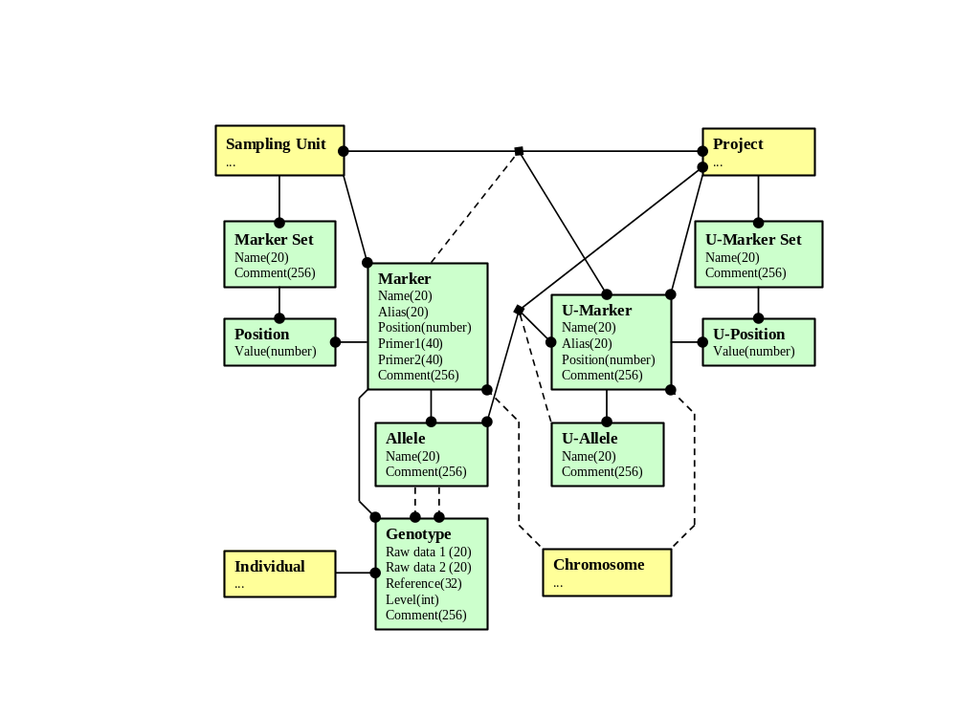
The logical model is mapped to the following physical model:

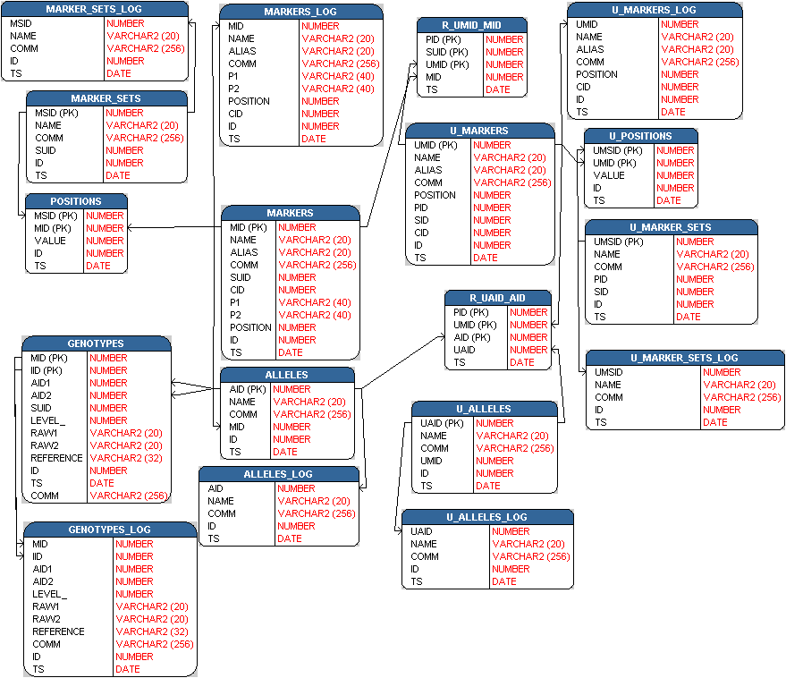

Table U_Markers
Column | Type | Null | Comment
Umid | Number(38) | No | Primary key with range 1001 – 2000000000.
Name | Varchar2(20) | No | Name of the unified marker, must be unique together with pid and sid.
Alias | Varchar2(20) | Yes | Alternative name
Comm | Varchar2(256) | Yes | Comment.
Position | Number | Yes | Absolute genetic position (cM)
Pid | Number(38) | No | References the column pid in table Projects. Not declared as FOREIGN KEY.
Sid | Number(38) | No | References the column sid in table Species. Not declared as FOREIGN KEY.
Cid | Number(38) | No | References the column cid in table Chromosomes. Not declared as FOREIGN KEY.
Id | Number(38) | No | References the column id in table Users. Not declared as FOREIGN KEY.
Ts | Date | No | Date the unified marker was updated.

Table U_Markers_Log
Column | Type | Null | Comment
Umid | Number(38) | No | References the column umid in table U_Markers. Not declared as FOREIGN KEY.
Name | Varchar2(20) | No | Name of the unified marker.
Alias | Varchar2(20) | Yes | Alternative name
Comm | Varchar2(256) | Yes | Comment.
Position | Number | Yes | Absolute genetic position (cM)
Cid | Number(38) | No | References the column cid in table Chromosomes. Not declared as FOREIGN KEY.
Id | Number(38) | No | References the column id in table Users. Not declared as FOREIGN KEY.
Ts | Date | No | Date the unified marker was updated.

Table U_Marker_Sets
Column | Type | Null | Comment
Umsid | Number(38) | No | Primary key with range 1001 – 2000000000.
Name | Varchar2(20) | No | Name of this unified marker set. Must be unique together with pid and sid.
Comm | Varchar2(256) | Yes | Comment.
Pid | Number(38) | No | References the column pid in table Projects. Not declared as FOREIGN KEY.
Sid | Number(38) | No | References the column sid in table Species. Not declared as FOREIGN KEY.
Id | Number(38) | No | References the column id in table Users. Not declared as FOREIGN KEY.
Ts | Date | No | Date this unified marker set was updated.

Table U_Marker_Sets_Log
Column | Type | Null | Comment
Umsid | Number(38) | No | References the column umsid in table U_Marker_Sets. Not declared as FOREIGN KEY.
Name | Varchar2(20) | No | Name of this unified marker set.
Comm | Varchar2(256) | Yes | Comment.
Id | Number(38) | No | References the column id in table Users. Not declared as FOREIGN KEY.
Ts | Date | No | Date this unified marker set was updated.

Table U_Alleles
Column | Type | Null | Comment
Uaid | Number(38) | No | Primary key with range 1001 – 2000000000.
Name | Varchar2(20) | No | Name of this unified allele. Must be unique together with umid.
Comm | Varchar2(256) | Yes | Comment.
Umid | Number(38) | No | References the column umid in table U_Markers. Not declared as FOREIGN KEY.
Id | Number(38) | No | References the column id in table Users. Not declared as FOREIGN KEY.
Ts | Date | No | Date/time of update.

Table U_Alleles_Log
Column | Type | Null | Comment
Uaid | Number(38) | No | References the column uaid in table U_Alleles. Not declared as FOREIGN KEY.
Name | Varchar2(20) | No | Name of this unified allele.
Comm | Varchar2(256) | Yes | Comment.
Id | Number(38) | No | References the column id in table Users. Not declared as FOREIGN KEY.
Ts | Date | No | Date/time of update.

Table Markers
Column | Type | Null | Comment
Mid | Number(38) | No | Primary key with range 1001 – 2000000000.
Name | Varchar2(20) | No | Name of the marker, must be unique together with suid.
Alias | Varchar2(20) | Yes | Alternative name
Comm | Varchar2(256) | Yes | Comment.
Suid | Number(38) | No | References the column suid in table Sampling_Units. Not declared as FOREIGN KEY.
Cid | Number(38) | No | References the column cid in table Chromosomes. Not declared as FOREIGN KEY.
P1 | Varchar2(40) | Yes | Primer 1
P2 | Varchar2(40) | Yes | Primer 2
Position | Number | Yes | Absolute genetic position (cM)
Id | Number(38) | No | References the column id in table Users. Not declared as FOREIGN KEY.
Ts | Date | No | Date and timer for update.

Table Markers_Log
Column | Type | Null | Comment
Mid | Number(38) | No | References the column mid in table Markers. Declared as FOREIGN KEY ON DELETE CASCADE.
Name | Varchar2(20) | No | Name of the marker.
Alias | Varchar2(20) | Yes | Alternative name
Comm | Varchar2(256) | Yes | Comment.
P1 | Varchar2(40) | Yes | Primer 1
P2 | Varchar2(40) | Yes | Primer 2
Position | Number | Yes | Absolute genetic position (cM)
Cid | Number(38) | No | References the column cid in table Chromosomes. Not declared as FOREIGN KEY.
Id | Number(38) | No | References the column id in table Users. Not declared as FOREIGN KEY.
Ts | Date | No | Date and timer for update.

Table Marker_Sets
Column | Type | Null | Comment
Msid | Number(38) | No | Primary key with range 1001 – 2000000000.
Name | Varchar2(20) | No | Name of the marker set. Must be unique together with suid.
Comm | Varchar2(256) | Yes | Comment.
Suid | Number(38) | No | References the column suid in table Sampling_Units. Not declared as FOREIGN KEY.
Id | Number(38) | No | References the column id in table Users. Not declared as FOREIGN KEY.
Ts | Date | No | Date/time marker set was updated.

Table Marker_Sets_Log
Column | Type | Null | Comment
Msid | Number(38) | No | References the column msid in table Marker_Sets. Declared as FOREIGN KEY ON DELETE CASCADE.
Name | Varchar2(20) | No | Name of the marker set.
Comm | Varchar2(256) | Yes | Comment.
Id | Number(38) | No | References the column id in table Users. Not declared as FOREIGN KEY.
Ts | Date | No | Date/time marker set was updated.

Table Alleles
Column | Type | Null | Comment
Aid | Number(38) | No | Primary key with range 1001 – 2000000000.
Name | Varchar2(20) | No | Name of the allele, must be unique together with mid.
Comm | Varchar2(256) | Yes | Comment.
Mid | Number(38) | No | References the column mid in table Markers. Declared as FOREIGN KEY ON DELETE CASCADE.
Id | Number(38) | No | References the column id in table Users. Not declared as FOREIGN KEY.
Ts | Date | No | Date/time allele was updated.

Table Alleles_Log
Column | Type | Null | Comment
Aid | Number(38) | No | References the column aid in table Alleles. Declared as FOREIGN KEY ON DELETE CASCADE.
Name | Varchar2(20) | No | Name of the allele.
Comm | Varchar2(256) | Yes | Comment.
Id | Number(38) | No | References the column id in table Users. Not declared as FOREIGN KEY.
Ts | Date | No | Date/time allele was updated.

Table Genotypes
Column | Type | Null | Comment
Mid | Number(38) | No | Primary key, references the column mid in table Markers. Not declared as FOREIGN KEY.
Iid | Number(38) | No | Primary key, references the column iid in table Individuals. Not declared as FOREIGN KEY.
Aid1 | Number(38) | Yes | References the column aid in table Allele. Not declared as FOREIGN KEY.
Aid2 | Number(38) | Yes | References the column aid in table Allele. Not declared as FOREIGN KEY.
Suid | Number(38) | No | References the column suid in table Sampling_Units. Not declared as FOREIGN KEY.
Level_ | Number(38) | No | Security level (0 – 9)
Raw1 | Varchar2(20) | Yes | Raw data for allele 1
Raw2 | Varchar2(20) | Yes | Raw data for allele 2
Reference | Varchar2(32) | Yes | Raw data reference, e.g. gel
Id | Number(38) | No | References the column id in table Users. Not declared as FOREIGN KEY.
Ts | Date | No | Date/time genotype was update.
Comm | Varchar2(256) | Yes | Comment

Table Genotypes_Log
Column | Type | Null | Comment
Mid | Number(38) | No | References the column mid in table Markers. Declared as FOREIGN KEY ON DELETE CASCADE.
Iid | Number(38) | No | References the column iid in table Individuals. Declared as FOREIGN KEY ON DELETE CASCADE.
Aid1 | Number(38) | Yes | References the column aid in table Allele. Not declared as FOREIGN KEY.
Aid2 | Number(38) | Yes | References the column aid in table Allele. Not declared as FOREIGN KEY.
Level_ | Number(38) | No | Security level (0 – 9)
Raw1 | Varchar2(20) | Yes | Raw data for allele 1
Raw2 | Varchar2(20) | Yes | Raw data for allele 2
Reference | Varchar2(32) | Yes | Raw data reference, e.g. gel
Comm | Varchar2(256) | Yes | Comment
Id | Number(38) | No | References the column id in table Users. Not declared as FOREIGN KEY.
Ts | Date | No | Date/time genotype was update.

Table U_Positions
Column | Type | Null | Comment
Umsid | Number(38) | No | Primary key, references the column umsid in table U_Marker_Sets. Declared as FOREIGN KEY ON DELETE CASCADE.
Umid | Number(38) | No | Primary key, references the column umid in table U_Markers. Declared as FOREIGN KEY ON DELETE CASCADE.
Value | Number | Yes | Position value, must be >= 0.
Id | Number(38) | No | References the column id in table Users. Not declared as FOREIGN KEY.
Ts | Date | No | Date/time this unified position was updated.

Table Positions
Column | Type | Null | Comment
Msid | Number(38) | No | Primary key, references column msid in table Marker_Sets. Declared as FOREIGN KEY ON DELETE CASCADE.
Mid | Number(38) | No | Primary key, references column mid in table Markers. Declared as FOREIGN KEY ON DELETE CASCADE.
Value | Number | Yes | Value of this position. Must be >= 0.
Id | Number(38) | No | References the column id in table Users. Not declared as FOREIGN KEY.
Ts | Date | No | Date/time this position was updated.

Table R_Umid_Mid
Column | Type | Null | Comment
Pid | Number(38) | No | Primary key, references column pid in table Projects. Declared as FOREIGN KEY ON DELETE CASCADE.
Suid | Number(38) | No | Primary key, references column suid in table Sampling_Units. Declared as FOREIGN KEY ON DELETE CASCADE.
Umid | Number(38) | No | Primary key, references column umid in table U_Markers. Declared as FOREIGN KEY ON DELETE CASCADE.
Mid | Number(38) | No | References the column mid in table Markers. Declared as FOREIGN KEY ON DELETE CASCADE.
Ts | Date | No | Date/time this relation was updated.

Table R_Uaid_Aid
Column | Type | Null | Comment
Pid | Number(38) | No | Primary key, references column pid in table Projects. Declared as FOREIGN KEY ON DELETE CASCADE.
Umid | Number(38) | No | Primary key, references column umid in table U_Markers. Declared as FOREIGN KEY ON DELETE CASCADE.
Aid | Number(38) | No | Primary key, references column aid in table Alleles. Declared as FOREIGN KEY ON DELETE CASCADE.
Uaid | Number(38) | No | References the column uaid in table U_Alleles. Declared as FOREIGN KEY ON DELETE CASCADE.
Ts | Date | No | Date/time relation was updated.

Analyses
The logical model for analyses is displayed below. Refer to reference 1 for more details.
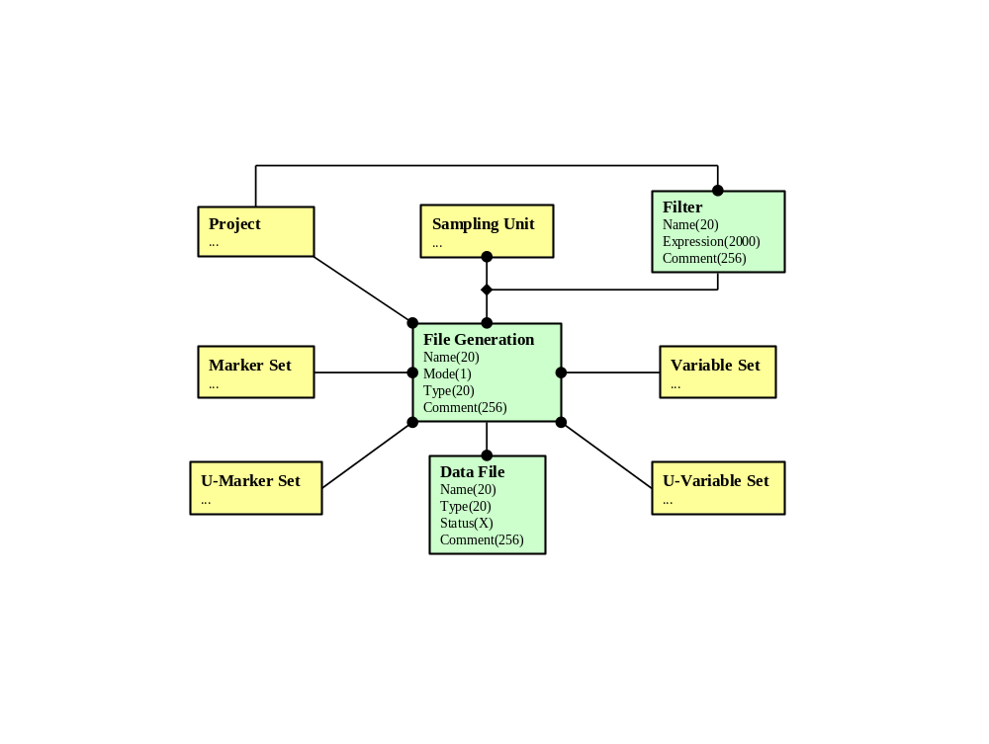
The logical model is mapped to the following physical model

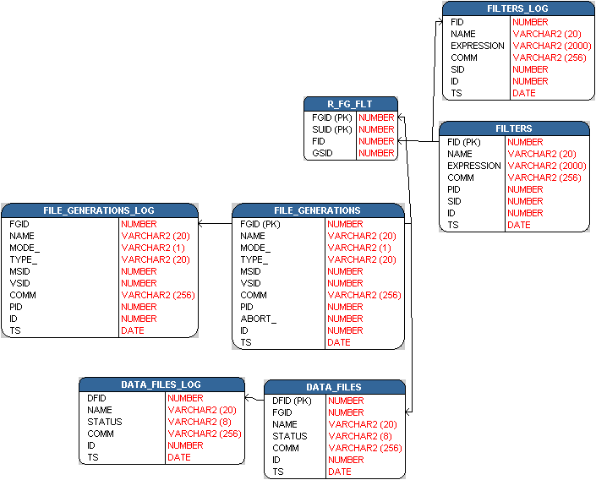

Table Filters
Column | Type | Null | Comment
Fid | Number(38) | No | Primary key with range 1001 – 2000000000.
Name | Varchar2(20) | No | Name of this GQL filter, must be unique together with pid.
Expression | Varchar2(2000) | Yes | GQL expression
Comm | Varchar2(256) | Yes | Comment.
Pid | Number(38) | No | References the column pid in table Projects. Not declared as FOREIGN KEY.
Sid | Number(38) | No | References the column Sid in table Species. Not declared as FOREIGN KEY.
Id | Number(38) | No | References the column id in table Users. Not declared as FOREIGN KEY.
Ts | Date | No | Date and time of filter creation.

Table Filters_Log
Column |  | Type | Null |  | Comment
Fid | Number(38) |  |  | No |  | References the column fid in table Filters. Declared as FOREIGN KEY ON DELETE CASCADE..
Name | Varchar2(20) |  |  | No |  | Name of this GQL filter, must be unique together with pid.
Expression | Varchar2(2000) |  |  | Yes |  | GQL expression
Comm | Varchar2(256) |  |  | Yes |  | Comment.
Sid | Number(38) |  |  | No |  | References the column Sid in table Species. Not declared as FOREIGN KEY.
Id | Number(38) |  |  | No |  | References the column id in table Users. Not declared as FOREIGN KEY.
Ts | Date |  |  | No |  | Date and time of filter creation.

Table File_Generations
Column | Type | Null | Comment
Fgid | Number(38) | No | Primary key with range 1001 – 2000000000.
Name | Varchar2(20) | No | Name of this generation. Must be unique together with pid.
Mode_ | Varchar2(1) | No | Mode of this generation. Valid values: ‘S’ and ‘M’. (Single and Multi)
Type_ | Varchar2(20) | No | Type, e.g. LINKAGE or CRIMAP
Msid | Number(38) | Yes | References the column msid in table Marker_Sets. Not declared as FOREIGN KEY.
Vsid | Number(38) | Yes | References the column vsid in table Variable_Sets. Not declared as FOREIGN KEY.
Comm | Varchar2(256) | Yes | Comment.
Pid | Number(38) | No | References the column id in table Projects. Not declared as FOREIGN KEY.
Abort_ | Number(38) | No | Used for abort signal
Id | Number(38) | No | References the column id in table Users. Not declared as FOREIGN KEY.
Ts | Date | No | Date and time this generation was updated.

Table File_Generations_Log
Column | Type | Null | Comment
Fgid | Number(38) | No | References the column fgid in table File_Generations. Not declared as FOREIGN KEY
Name | Varchar2(20) | No | Name of this generation.
Mode_ | Varchar2(1) | No | Mode of this generation. Valid values: ‘S’ and ‘M’. (Single and Multi)
Type_ | Varchar2(20) | No | Type, e.g. LINKAGE or CRIMAP
Msid | Number(38) | No | References the column msid in table Marker_Sets. Not declared as FOREIGN KEY.
Vsid | Number(38) | No | References the column vsid in table Variable_Sets. Not declared as FOREIGN KEY.
Comm | Varchar2(256) | Yes | Comment.
Pid | Number(38) | No | References the column id in table Projects. Not declared as FOREIGN KEY.
Id | Number(38) | No | References the column id in table Users. Not declared as FOREIGN KEY.
Ts | Date | No | Date and time this generation was updated.

Table Data_Files
Column | Type | Null | Comment
Dfid | Number(38) | No | Primary key with range 1001 – 2000000000.
Fgid | Number(38) | No | References the column fgid in table File_Generations. Not declared as FOREIGN KEY.
Name | Varchar2(20) | No | Name of this data file. Must be unique together with fgid.
Status | Varchar2(8) | Yes | Completion status of this data file.
Comm | Varchar2(256) | Yes | Comment.
Id | Number(38) | No | References the column id in table Users. Not declared as FOREIGN KEY.
Ts | Date | No | Date and time the file was created.

Table Data_Files_Log
Column | Type | Null | Comment
Dfid | Number(38) | No | References the column dfid in table Data_Files. Declared as FOREIGN KEY ON DELETE CASCADE.
Name | Varchar2(20) | No | Name of this data file.
Status | Varchar2(8) | Yes | Completion status of this data file.
Comm | Varchar2(256) | Yes | Comment.
Id | Number(38) | No | References the column id in table Users. Not declared as FOREIGN KEY.
Ts | Date | No | Date and time the file was created.

Table R_Fg_Flt
Column | Type | Null | Comment
Fgid | Number(38) | No | Primary key, references the column fgid in table File_Generations. Declared as FOREIGN KEY ON DELETE CASCADE.
Suid | Number(38) | No | Primary key, references the column suid in table Sampling_Units. Declared as FOREIGN KEY.
Fid | Number(38) | No | References the column fid in table Filters. Declared as FOREIGN KEY.
Gsid | Number(38) | Yes | References the column gsid in table Groupings. Declared as FOREIGN KEY.

Source files
This section describes the source files used to create the database tables.

Source file | Purpose
api_gdb_gql.sql | Creates procedures used by GQL
api_gdbp.sql | Creates the GDBP package
api_gdbp_b.sql | Creates the GDBP package body
api_misc.sql | Creates some miscellaneous procedures
db_env.sql | Data base environment
gdb_indexes.sql | Creates all DB indexes.
gdb_objects.sql | Creates all DB objects.
gdb_objects_nt.sql | Nt version of gdb_objects.sql
gdb_users.sql | Creates all DB users.
gdb_users_nt.sql | Nt version of gdb_users.sql
gdb_views.sql | Creates all DB views
gdb_views_gql.sql | Creates all DB views used by GQL
init_priv.sql | Initializes the privilege table

Development environment
SQL Plus and TOAD

Version Handling
Refer to reference 2.

References
- LL060a02 Arexis Genetic Database Tool – Functional Description, Prevas AB, 2002
- LL060c01 Arexis Genetic Database Tool – Design Specification, Prevas AB, 2002

Document Versions
Version | Date | Comment | Author
V1p1 | 2001-08-02 | Draft | ANNY
V1p2 | 2002-03-05 | Second draft | ANNY
V1 | 2002-05-21 | First version | FROB

